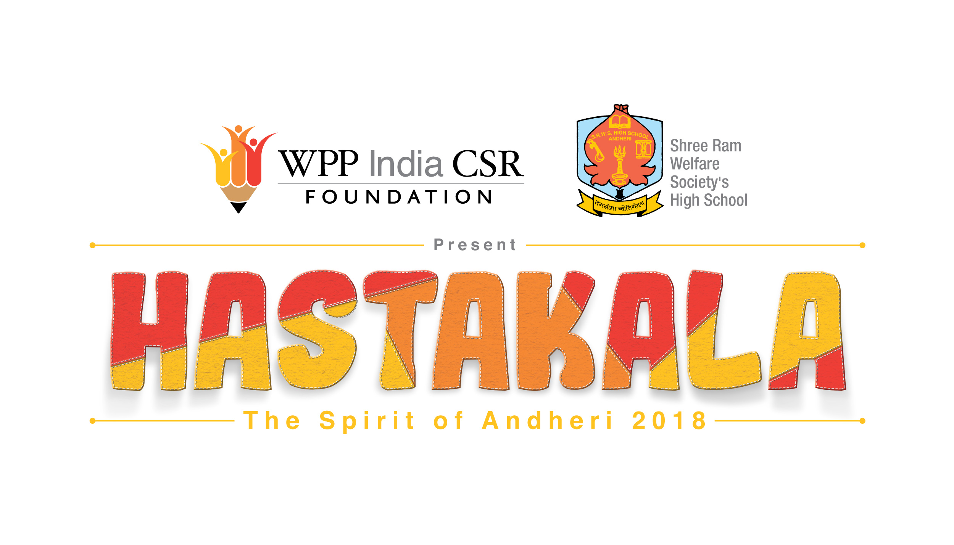

WPP India CSR Foundation and Shree Ram Welfare Society’s High School celebrate the ‘Spirit of Andheri’ at Hastakala 2018

November 2, 2018, Mumbai: Earlier this week, WPP India CSR Foundation partnered with Shree Ram Welfare Society’s High School to host Hastakala, an annual initiative created by the students, for the students. Taking place at the school premises, Hastakala aims to provide students a platform to develop communication, management, entrepreneurship and marketing skills along with showcasing their creative abilities.
Started in 2012 by the Shree Ram Welfare Society’s High School promoting the Skill Development India Project, Hastakala encourages young minds to explore the world of creativity as a pathway to their livelihood by building confidence, expressing their creativity and developing entrepreneurship skills.
For the first time, the initiative expanded its purview from being just an exhibition to a celebration of the community around the theme of ‘Spirit of Andheri’. Thousands of students showcased their creativity to highlight varied aspects of Andheri bringing alive its history, geography, transportation, fauna and flora and languages. From a 3D replica of the Gilbert Hill to complex language games, the students inspired the attendees to explore Andheri. The parents who themselves are entrepreneurs in the food industry, came together to host the food stalls for the day. An amount of over forty-two thousand was raised through the event.

Commenting on the success of the initiative and its impact, Rama Iyer, Director General, WPP India CSR Foundation said, ‘The Foundation aims to bring to life our vision, to lead the marginalised youth of India from education to livelihood by enhancing their learning journey and empowering them with opportunities to promote their work through a professional exhibition environment. It was delightful to see WPP India’s talented professionals come together and teach these young students to bring out their creativity while imbibing critical livelihood skills.”

Other exciting highlights
- The entirely student-led event, saw youngsters taking the lead on the entire process including event management, creation and sale of products. The funds raised at the event will be utilized by the school to promote student welfare
- WPP India’s very own Roshan Abbas, a celebrated Storyteller and Co-Founder of KOMMUNE hosted storytelling workshops with the students who later performed with him at the closing ceremony.
- Students showcased their talent through mehendi designing, building 3D Models, sewing recycled bags and crafting paper-quilled jewellery as well as their traditional Koli dancing talents
On this day, students who are first-generation learners got the opportunity to share with their parents what they learnt and also demonstrated the importance of education.

About WPP Foundation
Founded in 2015, the WPP India CSR Foundation strives to bring a social change through its flagship Education to Livelihood program(E2L). Addressing key focus areas—retention in school, poor learning outcomes, work skilling and deep-rooted social norms, the E2L program has been providing interventions and resources to 20,000 first generation learners from 11- 18 years. Currently, the program is running successfully in 10 underserved government aided schools across Mumbai and Delhi-NCR region. Through strategic partnerships with best-of-breed social organizations, the E2L program takes the evidence-based approach in developing frameworks and facilitate successful implementation. The foundation’s key initiatives include improving educational outcomes in literacy and numeracy, with a focus on opening young minds to the world of digital innovation. The Foundation also inculcates among the youth confidence, gender equality and the mindset and habits to be livelihood ready through counselling, sport, dance and music.

