WPP India CSR Foundation hosts its Annual Music Recital
400 children across WPP Foundation’s adopted schools performed
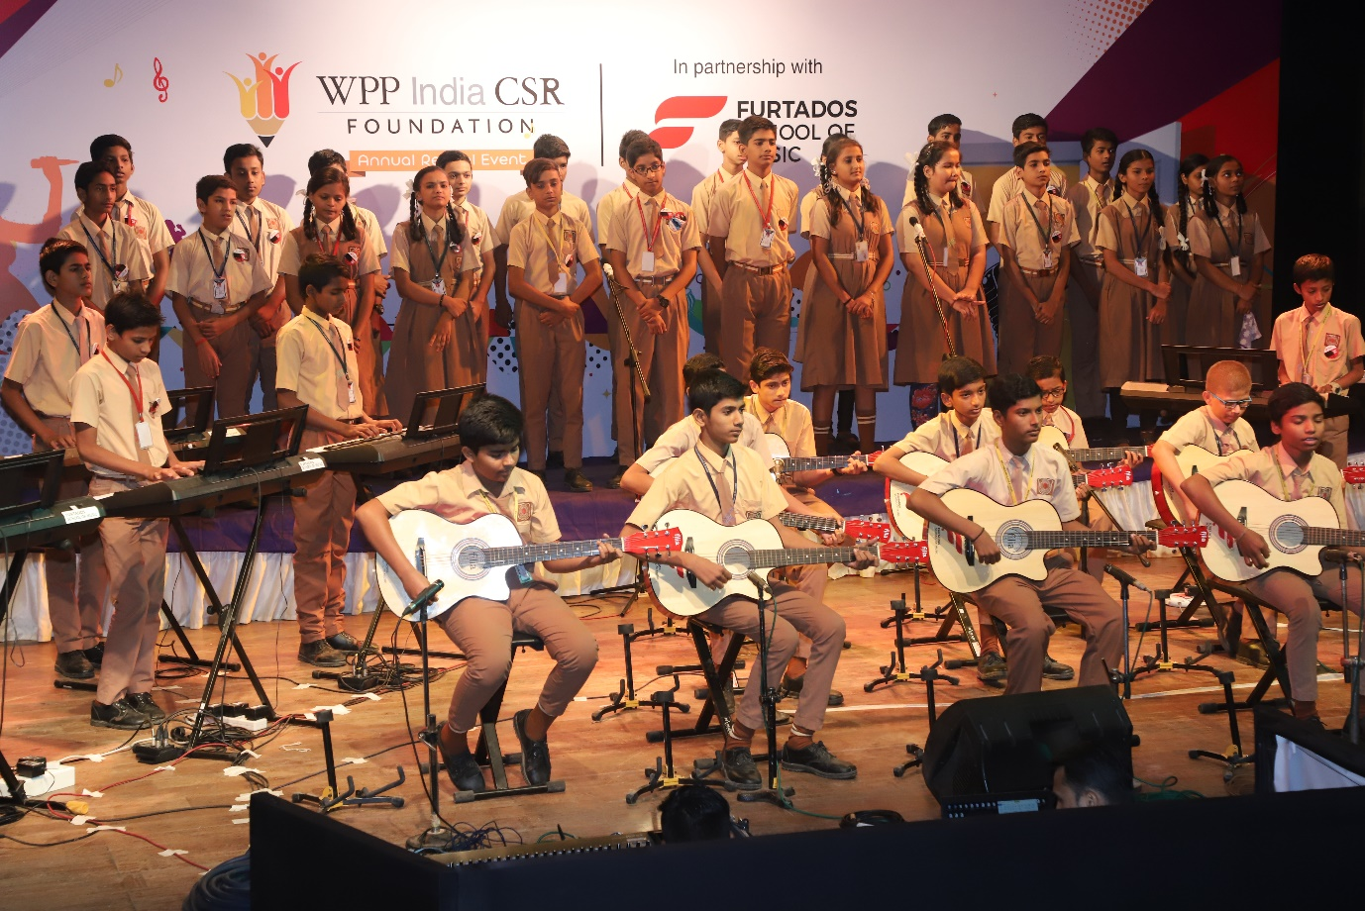
Mumbai, 19th March, 2019: WPP Foundation, the CSR entity of WPP India, in collaboration with Furtado’s School of Music today hosted its Annual Music Recital, an annual music program at the a Mumbai-suburban auditorium. The recital saw 400 children across two of WPP Foundation’s adopted schools perform a two-hour long recital as they completed the first academic year of their school music program.
The school music program was launched in 2018 by WPP Foundation across four schools adopted by the WPP Foundation. So far, 1000 children have been taught to read musical notes, rhythms and chords as well as trained in playing a key instrument based on their interests like an acoustic guitar or keyboards. Besides imparting professional music training to the children who otherwise may not have access to these opportunities, the program also aims to instill confidence in these young children to take up performing arts.
On the occasion, Rama Iyer – Director General, WPP Foundation said, “At WPP India Foundation and our flagship Education to Livelihood (E2L) program, we envision to create varied interventions to open doors of opportunities for our children in both mainstream and diverse livelihoods by providing them with holistic development. Aligned to this vision, we develop future skills in the field of professional music enabling our children to explore professional career options in music. It is a proud moment to

see our children performing together in such large numbers and stage such mesmerizing performances”.
About the WPP Foundation:
WPP is a creative transformation company that builds better futures for its clients through the integrated services of communications, experience, commerce and technology. WPP India launched the WPP India CSR Foundation in 2015. The vision is to help 20,000+ underserved children and youth in achieving their true potential. Together, we work in unison with partners towards bringing social change. The foundation is committed to a common CSR vision of opening doors for every child and youth from vulnerable and marginalised communities through our holistic child development programmes that focus on education, life skills and health. For more information, visit www.wppindiafoundation.com

Journey of the WPP India CSR Foundation
Founded in 2015, the WPP India CSR Foundation strives to bring about a social change through its flagship Education to Livelihood program(E2L). Addressing key focus areas—retention in school, poor learning outcomes, work skilling and deep-rooted social norms, the E2L program has been providing interventions and resources to 20,000 first-generation learners from 11- 18 years. Currently, the program is running successfully in 10 underserved government aided schools across the Mumbai and Delhi-NCR region. Through strategic partnerships with best-of-breed social organizations, the E2L program takes an evidence-based approach in developing frameworks to facilitate successful implementation.
The foundation’s key initiatives include improving educational outcomes in literacy and numeracy, with a focus on opening young minds to the world of digital innovation. The Foundation also helps to inculcate confidence, gender equality and the mindset and habits to be livelihood ready amongst the youth through counselling, sport, dance and music.
To ensure retention among the youth they support, they provide access to health education and health services.
In a remarkably short span of time, the E2L program has been able to
- Help over 70% children secure their future through employment or higher education
- Reduce dropout rates to less than 5%
- Initiate better health standards
- Double the ability of coding
- Reduce gender discrimination
- Increase literacy & numeracy
- Increase confidence levels
As a testimony of its sustained efforts to drive positive social impact, WPP Foundation has been recognised with several awards including Special Category Award for Livelihood at India International CSR Awards, 2018, Award for Best Business Campaign and Communication in CSR at the National Excellence in CSR Congress and Awards, 2018, Award for the Best CSR Impact Initiative at the National Excellence in CSR Congress and Awards, 2018 and National Recognition for Excellence in CSR at the

5th NHRDN-BIMTECH CSR Summit, 2018. They won a Special Commendation at the Golden Peacock Awards for CSR in January 2019. Recently, the Foundation also won the Best CSR Practices Award, Innovative CSR Practices and Women CSR Leadership Awards at the ET Now Presents CSR Awards, 2019

Media Contacts
Manasvi Khandelwal | manasvi.khandelwal@bm.com | +91 9769668090

